**Sayarti**

**Team members**

1. **Yazan Barakat - 411010698**
2. **Ali Mohammed Alatawi - 411006070**
3. **Raed Alharbi - 421000902**
4. **Ahmad Al Eisaa - 371002427**

**Advisor**

**Dr. Omar Asiri**

2022

### Introduction

“Sayarti” is an application that serve university students help by sending a report if the car broke down and can be fixed easily or if someone is parking behind him in a way that prevent him to move his car the app will notify the other car owner/ university authority to deal with the problem

Our Main Skate Holders Is University students, so This application is intended for universities use only, By providing a fast that allow students to help each other and communicate fast.

**Functional requirements of the project :**

1. Ask for assistance
2. Account Creation
3. Help other people
4. Report a car/person

**Non-functional requirements of the project :**

1. The style is consistent
2. Responsive and fast
3. Secure data
4. Easy to use

### The sketch

Figure 1 Sketch of Main / Ask For Help page functions

Figure 2 Sketch of Login / Register page functions

### 

Figure 3 Sketch of Help Others / Report Car page functions

### The Navigation map /wireframe

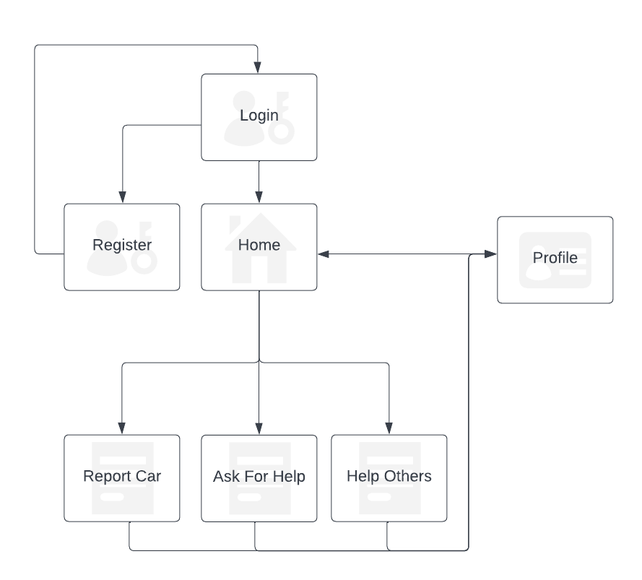

Figure 4 Navigation map of the app pages

### The Prototype

We Used The Prototype Tool “Axure” and made the following pages and you can test it live on this link <https://n3vbgj.axshare.com/>

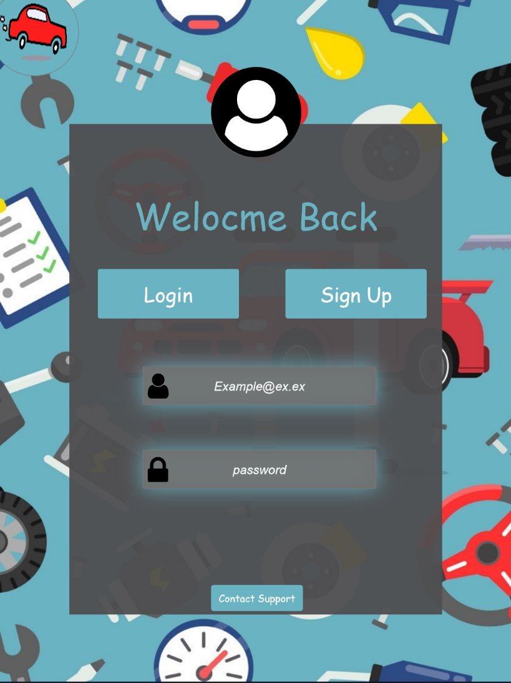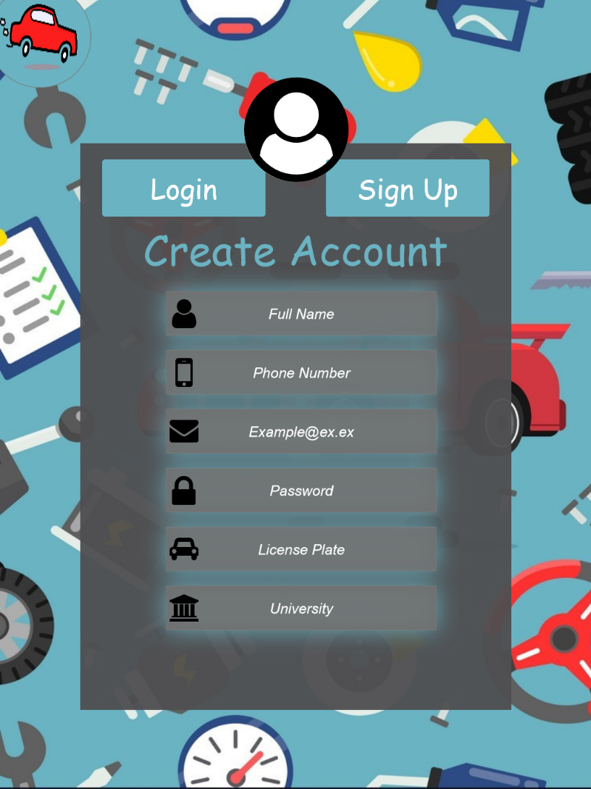

Figure 5 Login Page

Figure 6 Register Account

Here We Have The Frist Two Pages which have the functions of creating account / logging into an existing account

The login page take an email and a password and check them before allowing you to click login.

The account creation page will gather the most important information about the student like his name, University, license plate and other important data to match it later with the incoming reports.

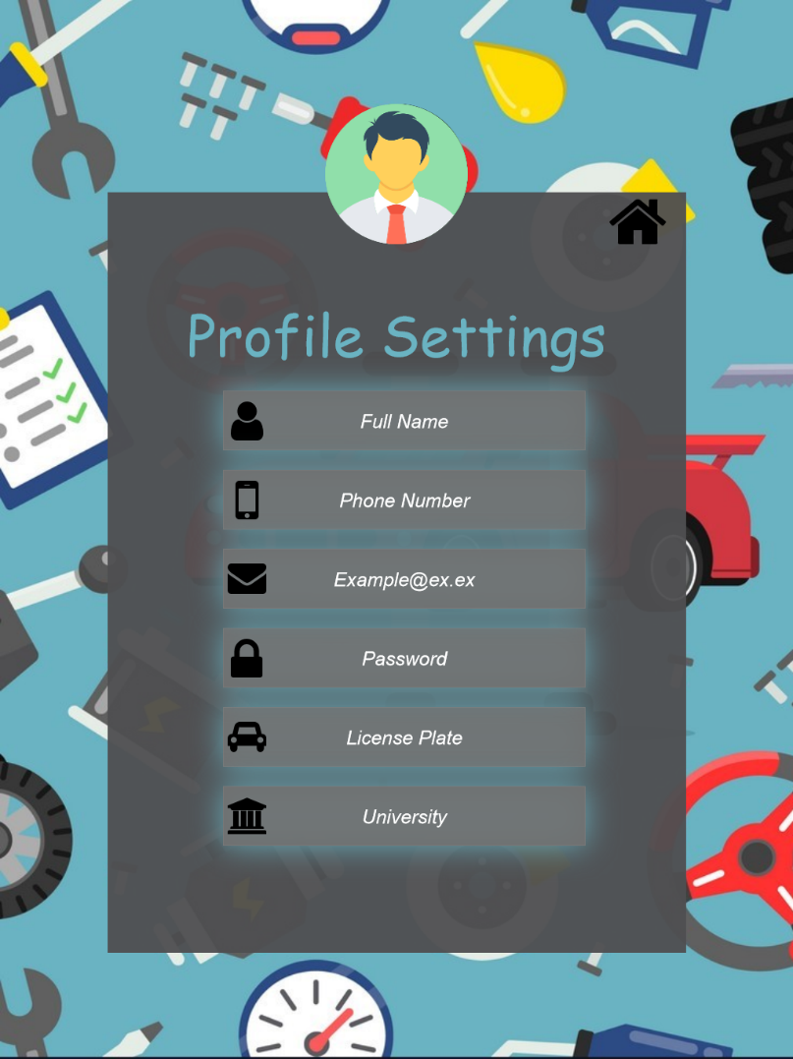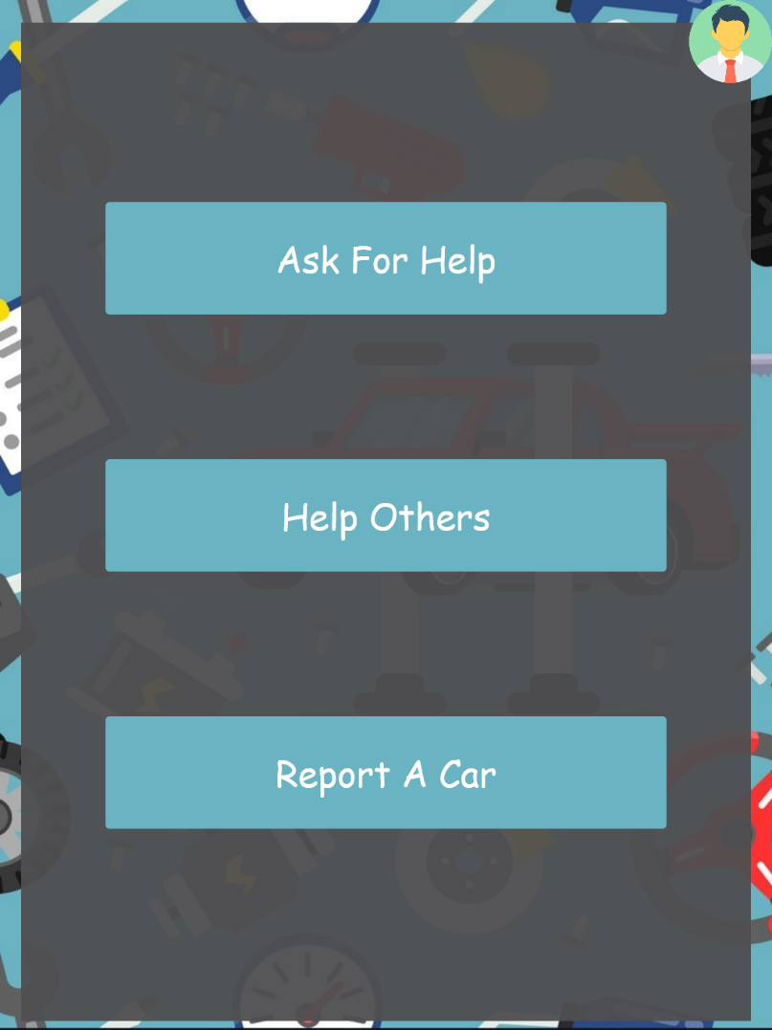After You Successfully login into your account you will be taken to the main page of the app and purpose of this page is straight forward you can choose one of the other available pages so it acts like a hub, also you can access your profile settings for this page.

Figure 7 Profile Page

Figure 8 Main Page

In the profile settings page you can see or edit your information and go back to main page.

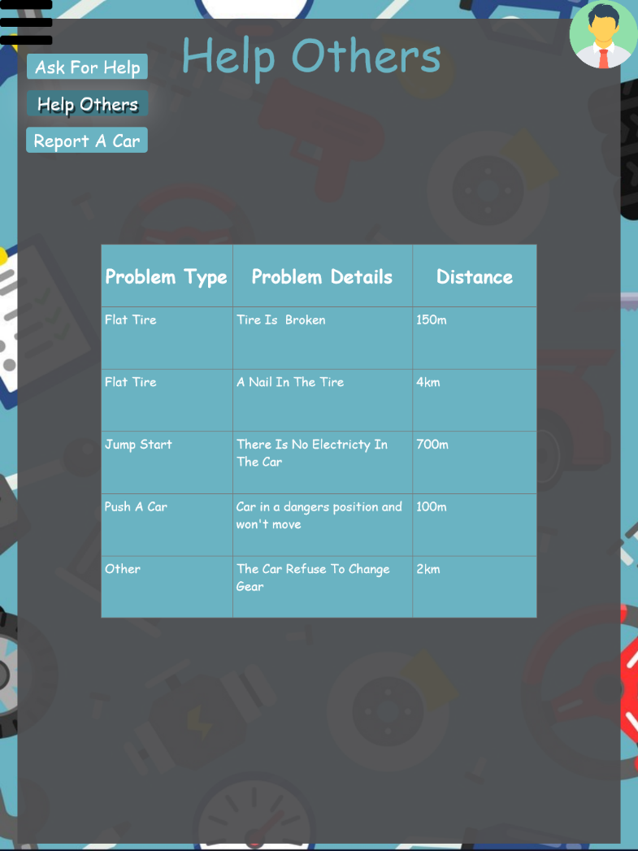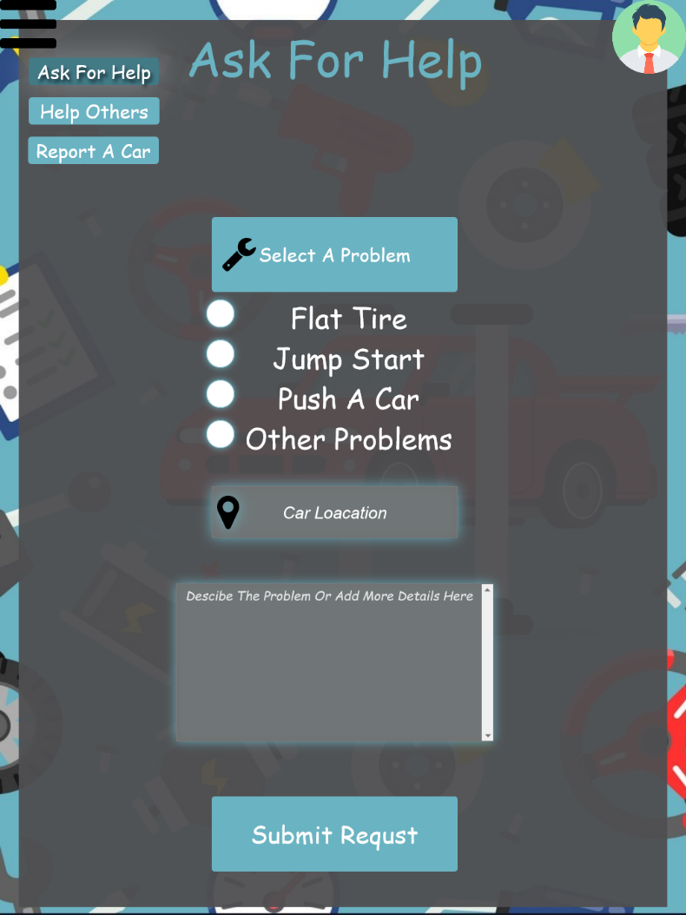

Figure 9 Help Others Page

Figure 10 Ask For Help Page

Here we show two of our most important pages.

In ask for help page you can select the type of problem you are facing with your car, your location, and any more details then sending a help request so any other user of the app can see your request from Help Other page.

Help Others Page is a simple straight forward page you can see request and how far they are from your location.

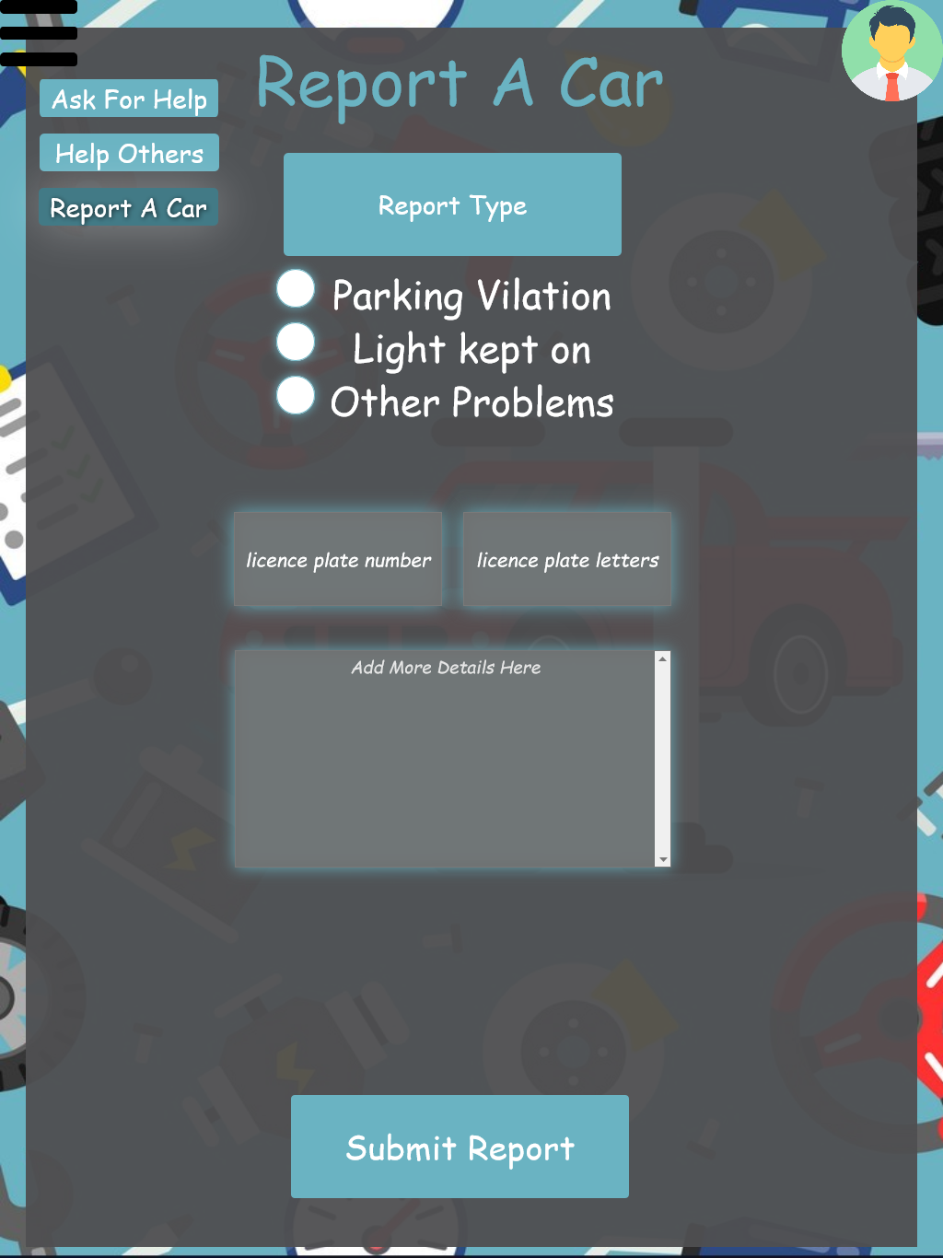

Figure 11 Report A Car Page

Lastly, we have Report A Car Page in this page you can send a notification to other car owners if they were blocking your car by entering their license plate information to match it with other users in the same university and also allow you to provide more information if needed.

### Future development

In the end we think the app is highly expandable and can receive many more updated like linking the application with the university ambulance center, Designing a map showing the traffic in a parking allow student and most importantly add some indicator to each help request that show it states and if someone is already on his way to help